Document Title | Document Code | Document Type | Issue No | Sop No.
Bug Fix | S-SW-BF | SOP | 01 | 4
Issue Date | Effective Date | Copy No. | Revision No.
01/10/2025 | 01/10/2025 | Master | 0

Purpose
Rapidly identify, prioritize, and resolve software defects to minimize business disruption and maintain service reliability.

Procedure & Flow
Step 1: Bug Reporting
- Action:
  - Submit via Bug form (screenshots, logs, environment details).
  - Classify severity:
    - Critical: System down/data loss
    - High: Major functionality broken
    - Medium: Minor defect
    - Low: Cosmetic
- Roles:
  - End User/Subsidiary Liaison: fill bug form.
Step 2: Triage & Assignment
- Action:
  - Software manager Receives bug form.
  - Software Tester reproduces bug; assigns severity/priority.
  - Software Supervisor Record Bug Log
  - Critical bugs trigger immediate war room (Hotfix).
- Roles:
  - Software supervisor: Assigns to developer.
  - Software Tester: Validates reproducibility.
Step 3: Fix Development
- Action:
  - Developer fixes code; peer review mandatory.
  - Testing added to prevent regression.
- Roles:
  - Assigned Developers: Writes fix.
  - Software Supervisor: Code review.
  - Software Tester.
Step 4: Validation & Deployment
- Action:
  - Software Tester in staging; verify with reporter.
  - Critical fixes deployed via hotfix pipeline.
- Roles:
  - Software Tester: Validation.
  - Software Supervisor: Deployment.
Step 5: Root Cause Analysis (RCA)
- Action:
  - Mandatory for critical/high bugs.
  - Update prevention mechanisms.
- Roles:
  - Software Tester: Leads Root Cause Analysis RCA.

Documents & Records
- Bug Form by Shared Service Coordinator (End User / Subsidiary)
- Bug Log by Software Supervisor.
- Hotfix Deployment Records by Developers Team.

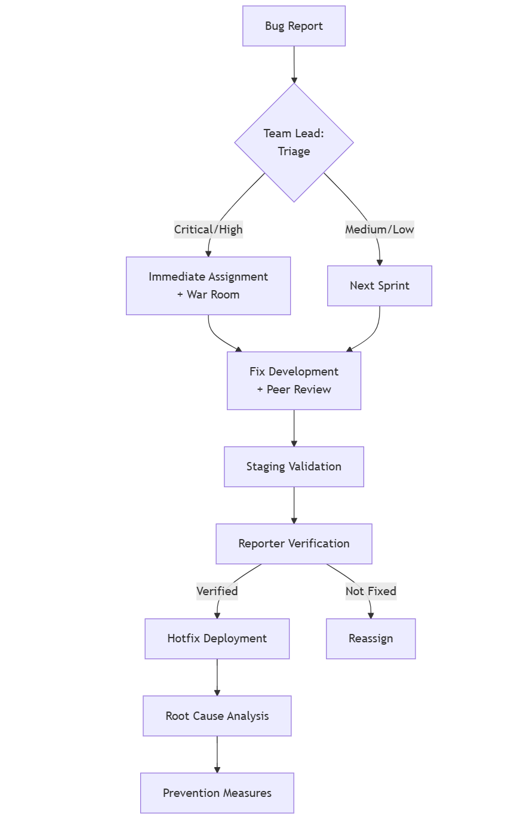
Forms
Form Name | Form Code
BUG FORM | F-SW-BF/01
BUGS LOG | F-SW-BF/02
BUGS TFS

Revision History
Rev No | Rev Date | Issue No | Issue Date | Description of Change | Approved By
0 | 01-10-2025 | 01 | 01-10-2025 | Initial Issue

